Software Design Specification

TMSO-SDS-001

Version 1.2

**Revision History**

| Date | Version | Description | Author | Revised by |
| --- | --- | --- | --- | --- |
| 23/06/2021 | 1.0 | Write Part 1: Introduction  Write Part 2: Fuctional Requirement:  + Add 5 workflow of project  + Update Specification of System Functions | Ho Si Hung | Ho Si Hung |
| 24/06/2021 | 1.1 | Update name of view controller  Write part 3: Database Desgin  Write part 4: Other Constraint | Ho Si Hung | Ho Si Hung |
| 24/06/2021 | 1.2 | Edit font (Times new roman->Arial)  Edit image order  Change logo and app name | Phan Duc | Phan Duc |
|  |  |  |  |  |
|  |  |  |  |  |
|  |  |  |  |  |
|  |  |  |  |  |

Table Content

1 Introduction 5

1.1 Overview 5

1.2 Scope 5

2 Functional Requirements 6

2.1 Architecture of System 6

2.1.1 Workflow 7

2.1.1.1 Running App Workflow 7

2.1.1.2 Categories Function Workflow 8

2.1.1.3 Bookmark Function Workflow 9

2.1.1.4 Download Function Workflow 11

2.1.1.5 Chart Function Workflow 13

2.2 Specification of System Functions 13

2.2.1 Feature/Component #1: Launch screen 13

2.2.1.1 User Interfaces 13

2.2.1.2 Functional Requirements 14

2.2.2 Feature/Component #2: Home screen 15

2.2.2.1 User Interfaces 15

2.2.2.2 Functional Requirements 17

2.2.3 Feature/Component #3: Detail News Screen 21

2.2.3.1 User Interfaces 21

2.2.3.2 Functional Requirements 21

2.2.4 Feature/Component #4: Categories screen 23

2.2.4.1 User Interfaces 23

2.2.4.2 Functional Requirements 23

2.2.5 Feature/Component #5: Category News List screen 27

2.2.5.1 User Interfaces 27

2.2.5.2 Functional Requirements 29

2.2.6 Feature/Component #6: Bookmarks Screen 33

2.2.6.1 User Interfaces 33

2.2.6.2 Functional Requirements 35

2.2.7 Feature/Component #7: Share Screen 38

2.2.7.1 User Interfaces 38

2.2.7.2 Functional Requirements 38

2.2.8 Feature/Component #8: Download list Screen 40

2.2.8.1 User Interfaces 40

2.2.8.2 Functional Requirements 42

2.2.9 Feature/Component #9: Getting News Screen 45

2.2.9.1 User Interfaces 45

2.2.9.2 Functional Requirements 45

2.2.10 Feature/Component #10: View chart Screen 46

2.2.10.1 User Interfaces 46

2.2.10.2 Functional Requirements 47

2.2.11 Feature/Component #11: No Internet Connection Screen 49

2.2.11.1 User Interfaces 49

2.2.11.2 Functional Requirements 49

3 Database Design 50

4 Other Constraints for Application 50

# Introduction

## Overview

This application allows users to read, bookmark and share the latest international news via API.

Users can also download news, store them inside their devices, and read them anytime they want.

Our application will get all latest news which then divided into 4 categories: Health, Technology, Entertainment, Science news. User can select a category to see news in that field.

This app also supports View chart for each category, users can select this function to see which categories they most usually visited.

Framework which we use in this project include:

* UIKit - UserInterface framework
* Core Data - To store Bookmarks in disk
* Swift Standard Library (Codable) - To parse JSON objects
* Charts - To draw chart

Library which we use in this project include:

* SDWebImage: to load image asynchronously
* SVProgressHUD: to display HUD screen with various status: loading/ processing/ success, …

## Scope

IOS OS version:

14.0

14.1

14.2

14.3

14.4

14.5

* Iphone test devices:
* iphone 8
* iphone 8 plus
* iphone X
* iphone Xs
* iphone Xs Max
* iphone Xr

Iphone screen resolutions:

750 x 1334 Pixels (iphone 8)

1920 x 1080 Pixels (iphone 8 plus)

2436x1125 Pixels (iphone X, iphone Xs)

2688 x 1242 Pixels (iphone Xs Max)

1792 × 828 Pixels (iphone Xr)

Support screen orientation in portrait mode only.

# Functional Requirements

## Architecture of System

### Workflow

#### Running App Workflow

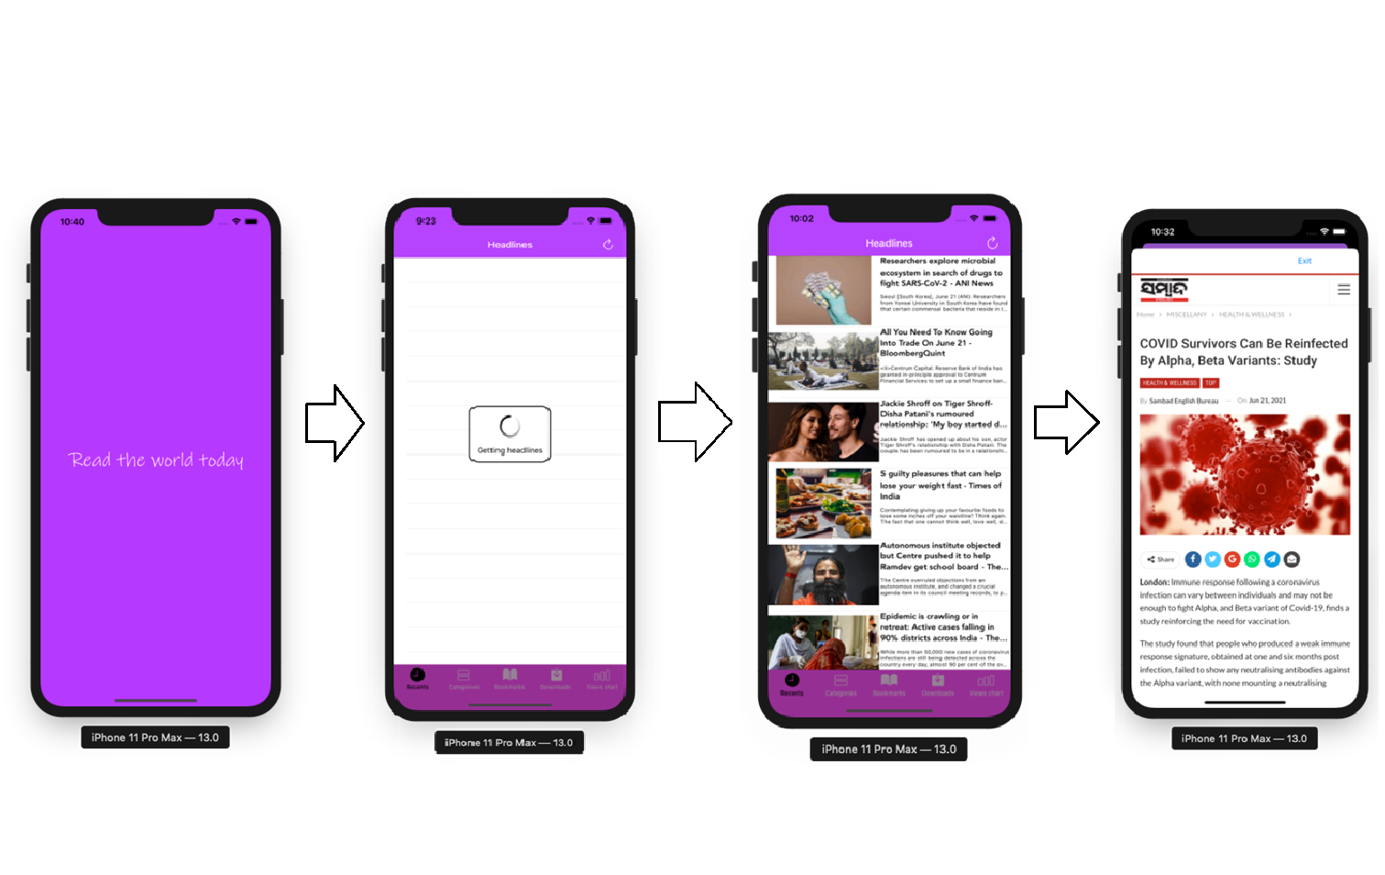

*Image 1: Workflow when running app*

From left to right is screen which is displayed when you open app. The first screen will be appeared as you launch application. After that, app will have to wait for a second to get all news, then all news will be displayed. You can see detail of news by selecting it.

#### Categories Function Workflow

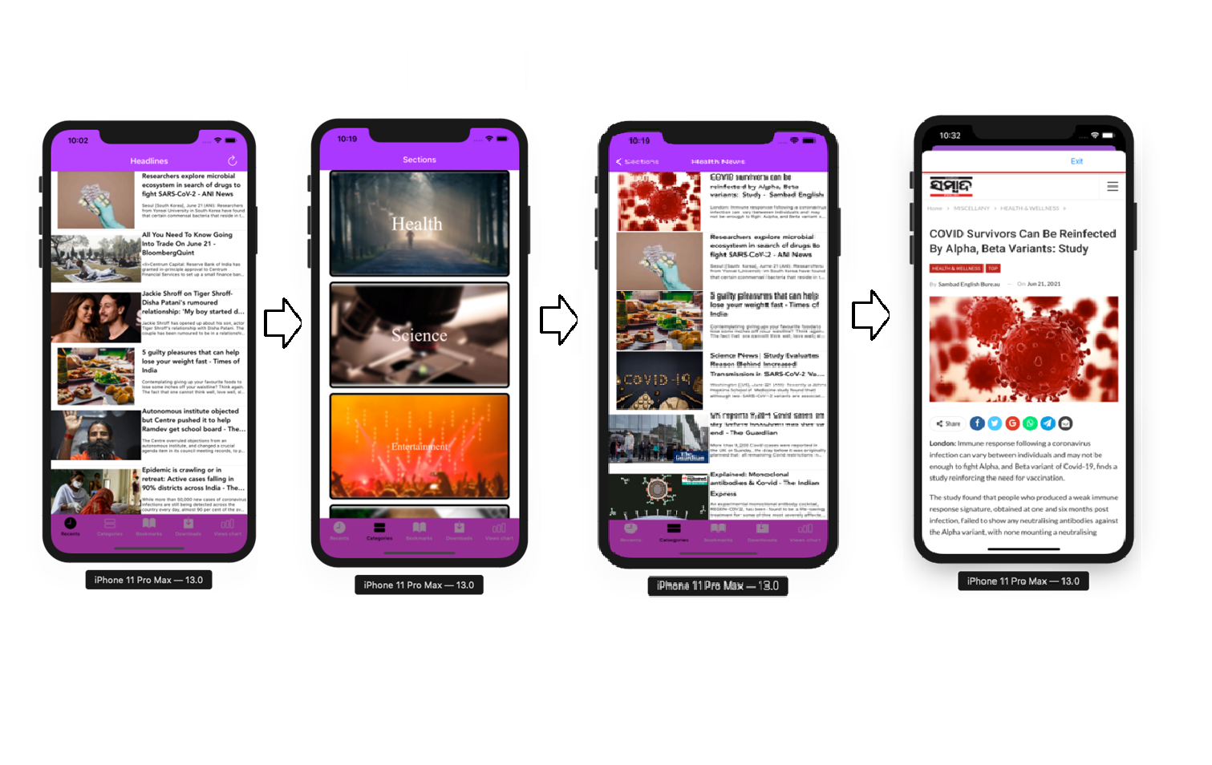

*Image 2: Workflow when choose Categories item at bottom bar*

From left to right is screen which is displayed when you choose Categories function. The first screen will be appeared as Home Screen. You can choose any category you want in 2nd screen. After that, a list of news in that categories will be displayed as 3rd screen. You can select a news to see its detail.

#### Bookmark Function Workflow

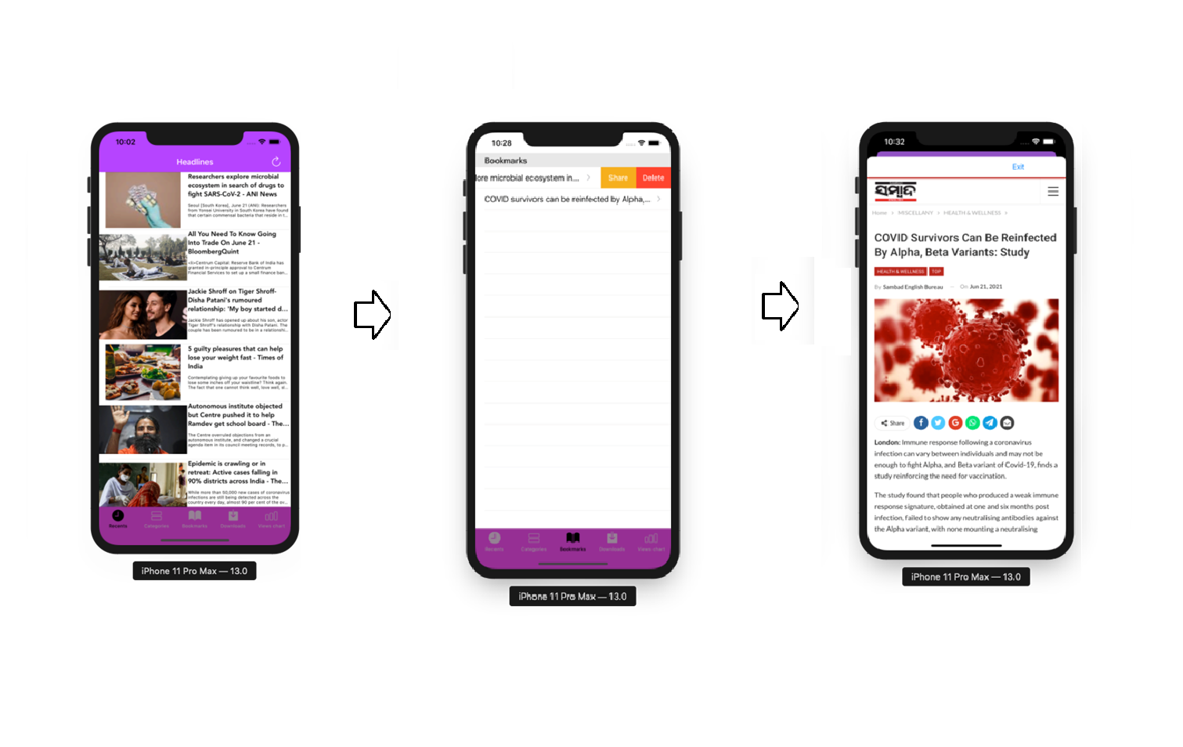

*Image 3: Workflow when choose Bookmark item at bottom bar*

From left to right is screen which is displayed when you choose Bookmark function. The first screen will be appeared as Home Screen. After that, a list of news that you have bookmarked will be displayed as 3rd screen. You can select a news to see its detail as screen 3 or select Share function, our app will show you a screen like this.

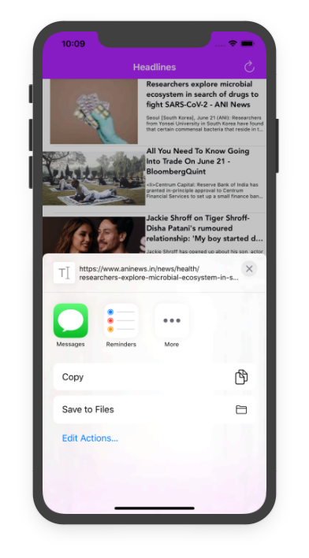

*Image 4: Share screen example*

#### Download Function Workflow

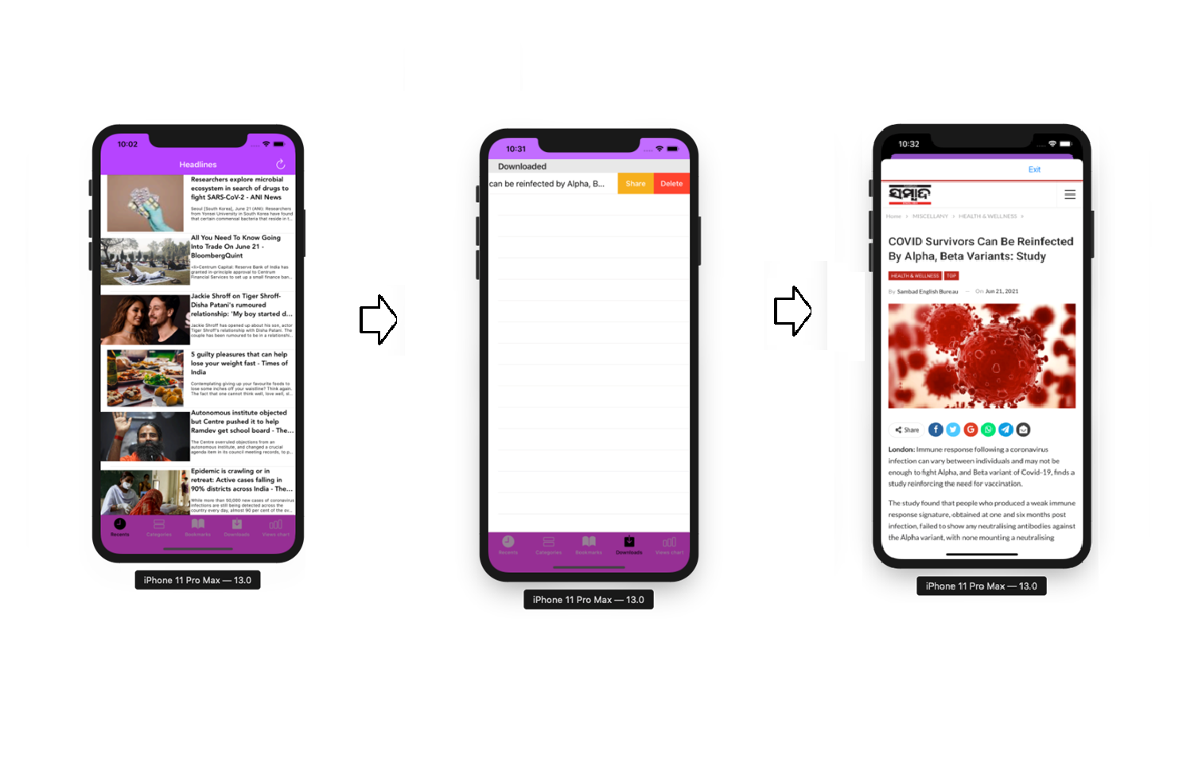

*Image 5: Workflow when choose Download item at bottom bar*

From left to right is screen which is displayed when you choose Download function. The first screen will be appeared as Home Screen. After that, a list of news that you have downloaded will be displayed as 3rd screen. You can select a news to see its detail as screen 3 or select Share function, our app will show you a screen like this.



*Image 6: Share screen example*

#### Chart Function Workflow

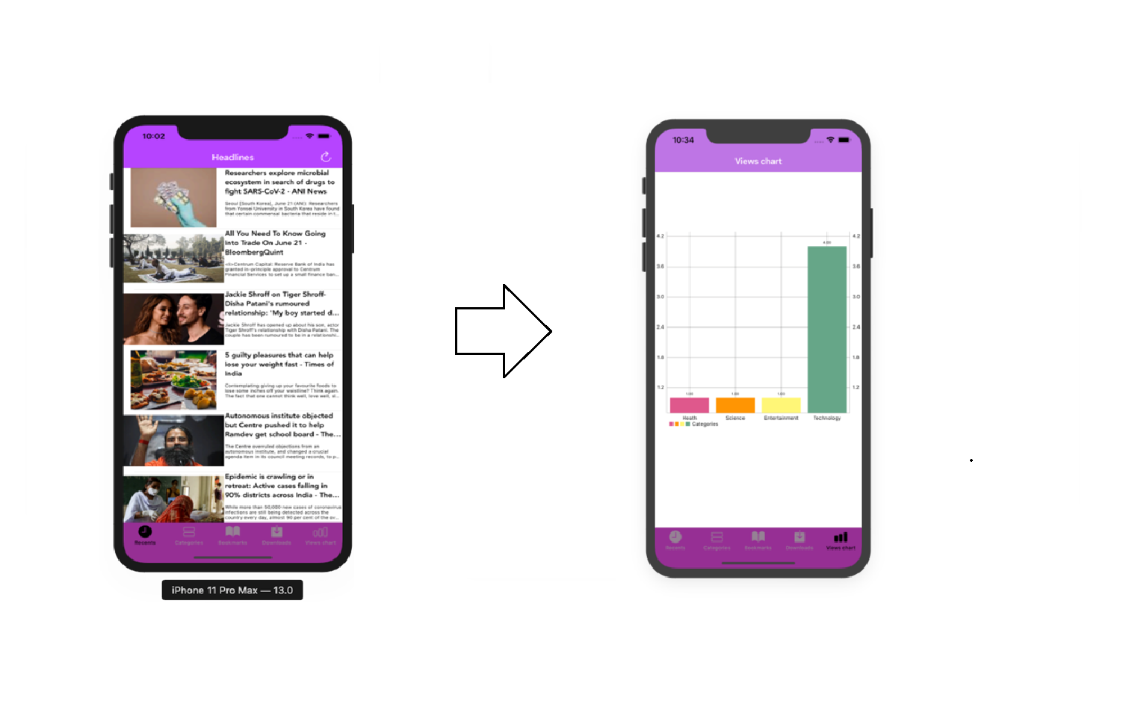

*Image 7: Workflow when choose Chart item at bottom bar*

From left to right is screen which is displayed when you choose chart function. The first screen will be appeared as Home Screen.The last screen will be displayed a view chart for each category.

## Specification of System Functions

### Feature/Component #1: Launch screen

#### User Interfaces

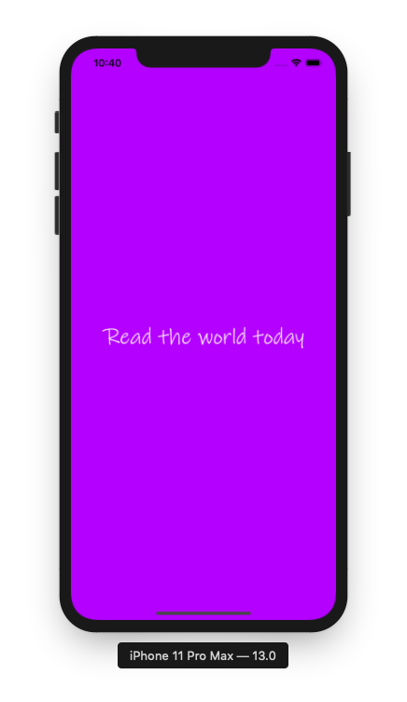

*Image 8: Launch screen*

#### Functional Requirements

|  |  |  |  |
| --- | --- | --- | --- |
| **Item** | **Description** | **Action** | **Response** |
| **Launch screen** | * Launch screen has a title: Read the world today * Text color: White * Background color: Violet | N/A | N/A |

### Feature/Component #2: Home screen

#### User Interfaces

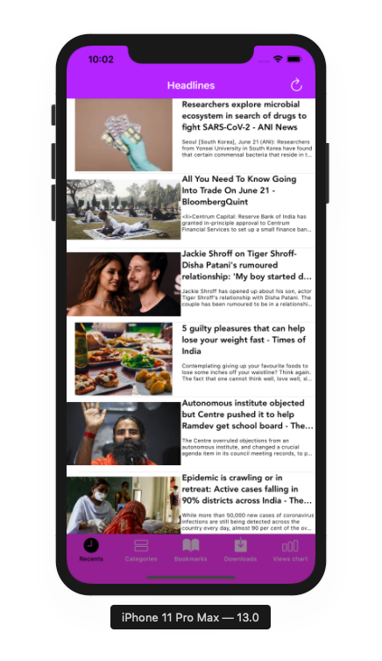

*Image 9: Home screen*

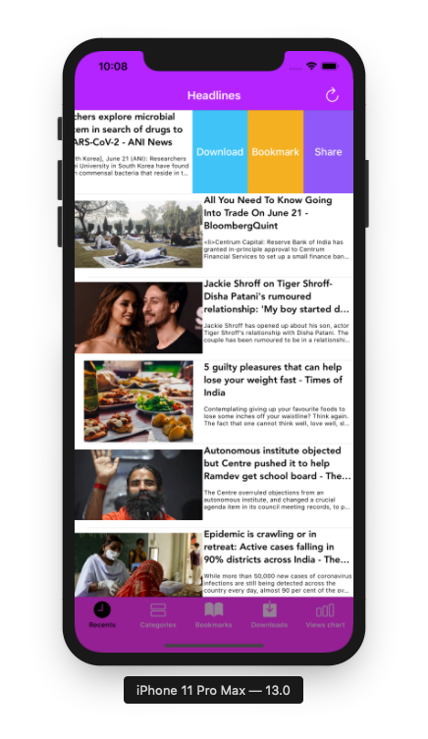

*Image 10: Home screen with Swipe Actions Download, Bookmark and Share*

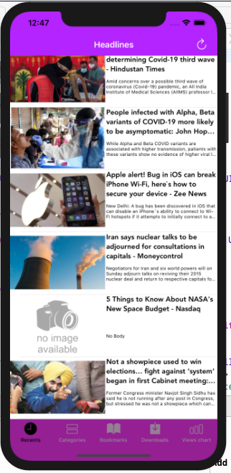

*Image 11: Home screen with an example of news*

*with error when loading image and content*

#### Functional Requirements

|  |  |  |  |
| --- | --- | --- | --- |
| **Item** | **Description** | **Action** | **Response** |
| **Home screen** | Home screen has 1 tabBarController, 5 tabBarItems,1 button, 1 navigationBar, and 20 view cells to display news data include images, title and body of that news:   * Navigation bar contain button refresh and title “Headlines: * View cell News contains these components: * News images * News Title * News Body * Download Swipe Action * Mark Swipe Action * Share Swipe Action * TabBarController contains 5 tabBarItems: * Recents TabBarItems * Categories TabBarItems * Bookmark TabBarItems * Download TabBarItems * View chart TabBarItems | N/A | N/A |
| **Navigation Bar** | Navigation bar contains a title of screen: “Headlines” and a refresh button | N/A | N/A |
| **Button refresh list news** | A button to refresh list news from api | Tap on the button | Create a network service object, get static property shareobj then call function getHeadLines. Which will send a request URL and then get data in JSON type, we need to convert that data into an array of Articles in Welcome.swift. After that, UITableViewCell will display our converted data. |
| **View cell News** | - Using to display news details  - View cell contains following components:   * Image news (if image can’t be loaded succesfully, no image availabe will be used to display) * Title news (if title can’t be loaded succesfully, “Not Found” will be used to display) * News summary (if title can’t be loaded succesfully, “No body” will be used to display) | Tap on the view cell | Use a segue to pass 2 parameters: url and title of selected new to Detail News screen. After that, BrowserVC controller will use webkit view to load html and then display into the screen. |
| **View cell News when swipe from right to left** | - Using to display news details and other options with this news  - View cell contains following components:   * Title news * News summary * Download Swipe Action * Mark Swipe Action * Share Swipe Action | Swipe from right to left | Display 3 Swipe Actions: Download, Bookmark and Share |
| **Download Swipe Action** | - Using to add news to download list  - The download button is on the left of the mark Swipe action  - The download Swipe action has a blue background and white text color | Tap on the **Download** Swipe Action | Create selected news item Daritcle (using CoreData) with 2 saved properites: title and url. Then add them to Download list. |
| **Bookmark Swipe Action** | - Using to add news to bookmark list  - The bookmark swipe action is on the left of the share swipe action  - The bookmark swipe action has an orange background and white text color | Tap on the **Bookmark** Swipe Action | Create selected news item Daritcle (using CoreData) with 2 saved properites: title and url. Then add them to Bookmark list. |
| **Share Swipe Action** | - Using to display a list of social network options for sharing  - The Bookmark Swipe Action  is on the left of the share button  - The share Swipe Action has a violet background and white text color | Tap on the **Share** Swipe Action | Display a list of social network options for sharing |
| **TabBarController** | TabBarController contains 5 tabBarItems:   * Recents TabBarItems * Categories TabBarItems * Bookmark TabBarItems * Download TabBarItems * View chart TabBarItems | N/A | N/A |
| **Recents TabBarItems** | -Using to display 20 latest news | Tap on the **Recents TabBarItem** | Display a list of 20 latest news |
| **Categories TabBarItems** | - Using to display category options  - Categories:   * Heath * Science * Entertainment * Technology | Tap on **Categories TabBarItems** | Display categories screen |
| **Bookmark TabBarItems** | - Using to display the list of bookmarks news on device | Tap on **Bookmark TabBarItems** | Display screen contians a list of bookmark news |
| **Download TabBarItems** | - Using to display the list of download news on the smartphone | Tap on **Download TabBarItems** | Display screen contians a list of download news |
| **View chart TabBarItems** | * Using to show a chart of user View for each category | Tap on **View chart TabBarItems** | Show a screen display a chart of user View for each category |

### Feature/Component #3: Detail News Screen

#### User Interfaces

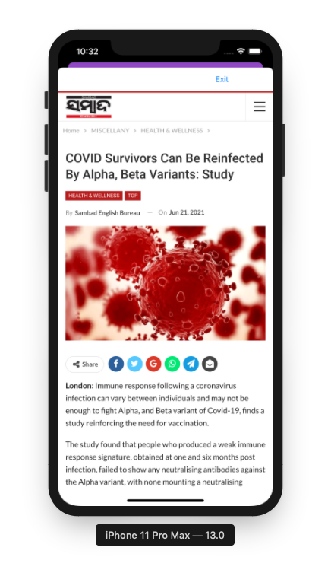

*Image 12: Detail News*

#### Functional Requirements

|  |  |  |  |
| --- | --- | --- | --- |
| **Item** | **Description** | **Action** | **Response** |
| **Detail News Screen** | Detail News Screen has 1 UIView contains an Exit button and an URL label.  It also contains a webkitview to display data of detail of news. | N/A | N/A |
| **UIView titleBarView** | UIView titleBarView has a constraint width equal to 320. | N/A | N/A |
| **Label URL** | Label URL has a gradient background, from purple on the left to pink on the right | N/A | N/A |
| **Exit button** | Using to exit screen detail news back to Home/Technology/Science/Entertainment/Heath screen | Tap on **Exit button** | Return to Home/Technology/Science/Entertainment/Heath screen |
| **WebkitView Detail News** | Using to show detail of selected news | N/A | N/A |

### Feature/Component #4: Categories screen

#### User Interfaces

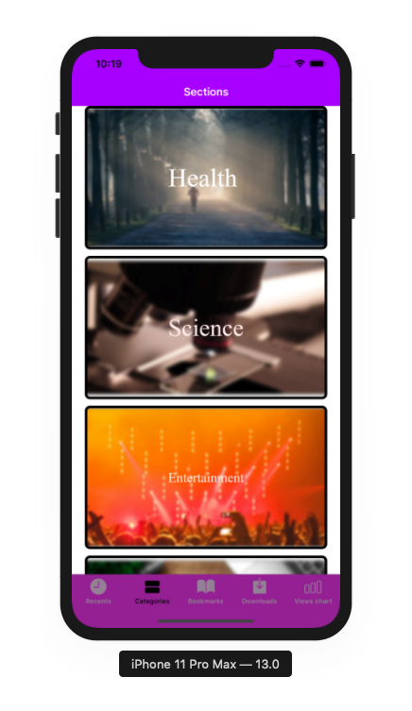

*Image 13: Categories screen*

#### Functional Requirements

|  |  |  |  |
| --- | --- | --- | --- |
| **Item** | **Description** | **Action** | **Response** |
| **Categories screen** | Screen has a navigationBar, 1 tabBarController, 5 tabBarItems, 1 CollectionView contains 4 CollectionViewcell:   * Navigation bar contains title “Sections” * TabBarController contains 5 tabBarItems: * Recents TabBarItems * Categories TabBarItems * Bookmark TabBarItems * Download TabBarItems * View chart TabBarItems * CollectionViewCell contains 2 UIImageView: background and categoryTitle | N/A | N/A |
| **Navigation Bar** | Navigation bar contains a title of screen: “Sections” | N/A | N/A |
| **TabBarController** | TabBarController contains 5 tabBarItems:   * Recents TabBarItems * Categories TabBarItems * Bookmark TabBarItems * Download TabBarItems * View chart TabBarItems | N/A | N/A |
| **Recents TabBarItems** | -Using to display 20 latest news | Tap on the **Recents TabBarItem** | Display a list of 20 latest news |
| **Categories TabBarItems** | - Using to display category options  - Categories:   * Heath * Science * Entertainment * Technology | Tap on **Categories TabBarItems** | Display categories screen |
| **Bookmark TabBarItems** | - Using to display the list of bookmarks news on device | Tap on **Bookmark TabBarItems** | Display screen contians a list of bookmark news |
| **Download TabBarItems** | - Using to display the list of download news on the smartphone | Tap on **Download TabBarItems** | Display screen contians a list of download news |
| **View chart TabBarItems** | Using to show a chart of user View for each category | Tap on **View chart TabBarItems** | Show a screen display a chart of user View for each category |
| **CollectionView Categories** | Using to show a list of 4 categories news: Health, Science, Entertainment, Technology | N/A | N/A |
| **CollectionViewCell Category** | Using to show detail of a category | Tap on **CollectionViewCell Category** | Use a segue to pass 1 parameter: index of selected cell. After that, app will move to **Category News list Screen,**  Then increase view of this category by one. It also received index of selected category and then will get news in that category by calling get…News function of NetworkService.sharedobj static properties. |
| **UIImageView background Category** | Using to show image of a category | N/A | N/A |
| **UIImageView title Category** | Using to show title image of a category | N/A | N/A |

### Feature/Component #5: Category News List screen

#### User Interfaces

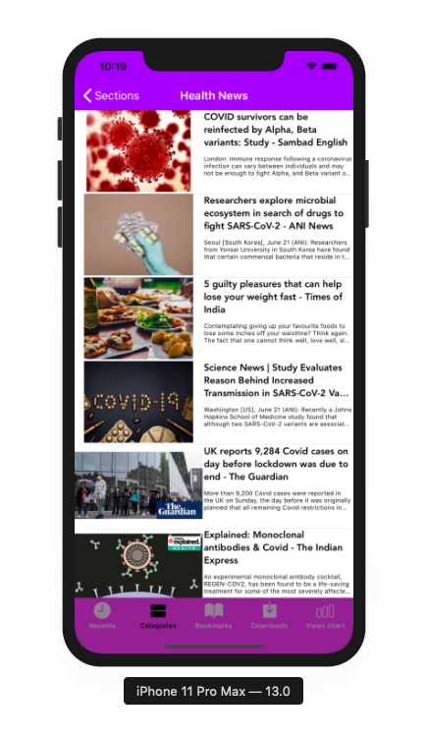

*Image 14: Categories News List screen*

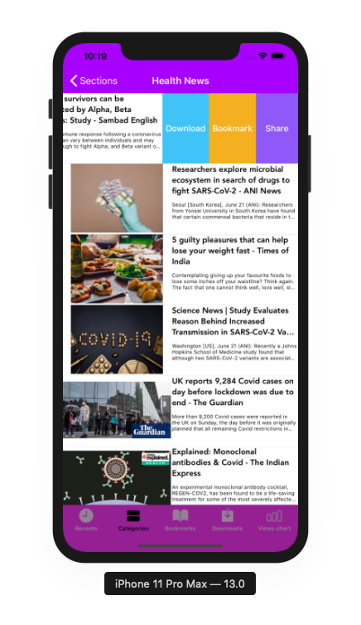

*Image 15: Categories News List screen with Swipe Actions Download, Bookmark and Share*

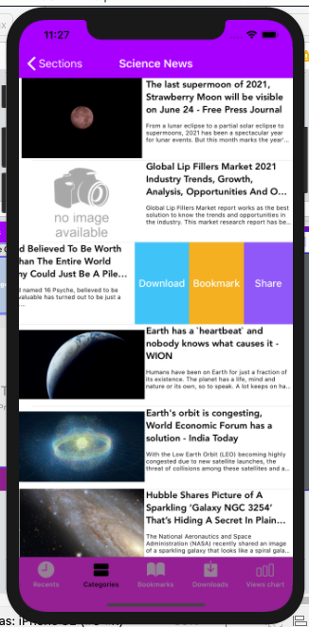

*Image 16: Categories News List screen with an example of news*

*with error when loading image and content*

#### Functional Requirements

|  |  |  |  |
| --- | --- | --- | --- |
| **Item** | **Description** | **Action** | **Response** |
| **Categories News List screen** | Categories News List screenhas 1 tabBarController, 5 tabBarItems,1 navigationBarItem, 1 navigationBar, and 20 view cells to display news data include images, title and body of that news:   * Navigation bar contain a navigationBar backToSections and title of selected category * View cell News contains these components: * News images * News Title * News Body * Download Swipe Action * Mark Swipe Action * Share Swipe Action * TabBarController contains 5 tabBarItems: * Recents TabBarItems * Categories TabBarItems * Bookmark TabBarItems * Download TabBarItems * View chart TabBarItems | N/A | N/A |
| **Navigation Bar** | Navigation bar contains a title of selected category and 1 navigationBarItem backToSections | N/A | N/A |
| **NavigationBarItem backToSections** | An **NavigationBarItem** to back to categories Screen | Tap on **NavigationBarItem backToSections** | Back to categories Screen |
| **View cell News** | - Using to display news details  - View cell contains following components:   * Image news (if image can’t be loaded succesfully, no image availabe will be used to display) * Title news (if title can’t be loaded succesfully, “Not Found” will be used to display) * News summary (if title can’t be loaded succesfully, “No body” will be used to display) | Tap on the view cell | Use a segue to pass 2 parameters: url and title of selected new to Detail News screen. After that, controller will use webkit view to load html and then display into the screen. |
| **View cell News when swipe from right to left** | - Using to display news details and other options with this news  - View cell contains following components:   * Title news * News summary * Download Swipe Action * Mark Swipe Action * Share Swipe Action | Swipe from right to left | Display 3 Swipe Actions: Download, Bookmark and Share |
| **Download Swipe Action** | - Using to add news to download list  - The download button is on the left of the mark Swipe action  - The download Swipe action has a blue background and white text color | Tap on the **Download** Swipe Action | Create selected news item Daritcle (using CoreData) with 2 saved properites: title and url. Then add them to Download list. |
| **Bookmark Swipe Action** | - Using to add news to bookmark list  - The bookmark swipe action is on the left of the share swipe action  - The bookmark swipe action has an orange background and white text color | Tap on the **Bookmark** Swipe Action | Create selected news item Daritcle (using CoreData) with 2 saved properites: title and url. Then add them to Bookmark list. |
| **Share Swipe Action** | - Using to display a list of social network options for sharing  - The Bookmark Swipe Action  is on the left of the share button  - The share Swipe Action has a violet background and white text color | Tap on the **Share** Swipe Action | Display a list of social network options for sharing |
| **TabBarController** | TabBarController contains 5 tabBarItems:   * Recents TabBarItems * Categories TabBarItems * Bookmark TabBarItems * Download TabBarItems * View chart TabBarItems | N/A | N/A |
| **Recents TabBarItems** | -Using to display 20 latest news | Tap on the **Recents TabBarItem** | Display a list of 20 latest news |
| **Categories TabBarItems** | - Using to display category options  - Categories:   * Heath * Science * Entertainment * Technology | Tap on **Categories TabBarItems** | Display categories screen |
| **Bookmark TabBarItems** | - Using to display the list of bookmarks news on device | Tap on **Bookmark TabBarItems** | Display screen contians a list of bookmark news |
| **Download TabBarItems** | - Using to display the list of download news on the smartphone | Tap on **Download TabBarItems** | Display screen contians a list of download news |
| **View chart TabBarItems** | * Using to show a chart of user View for each category | Tap on **View chart TabBarItems** | Show a screen display a chart of user View for each category |

### Feature/Component #6: Bookmarks Screen

#### User Interfaces

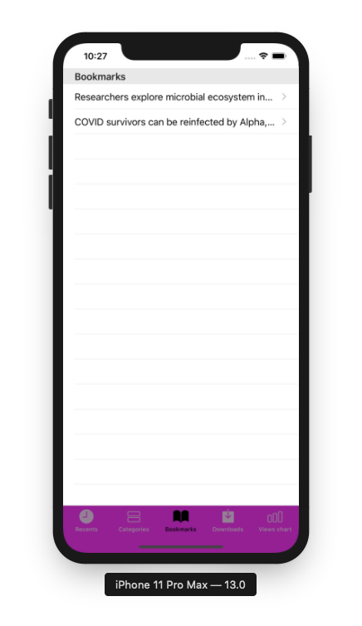

*Image 17: Bookmark screen*

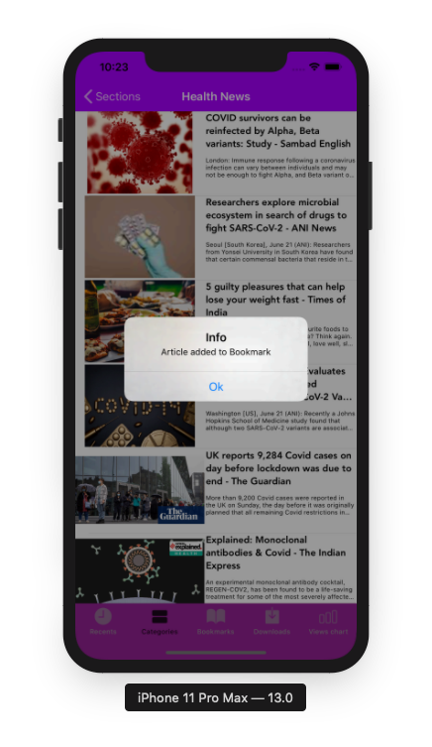

*Image 18: Notification when bookmarked successfully*

*at Categories News List screen*

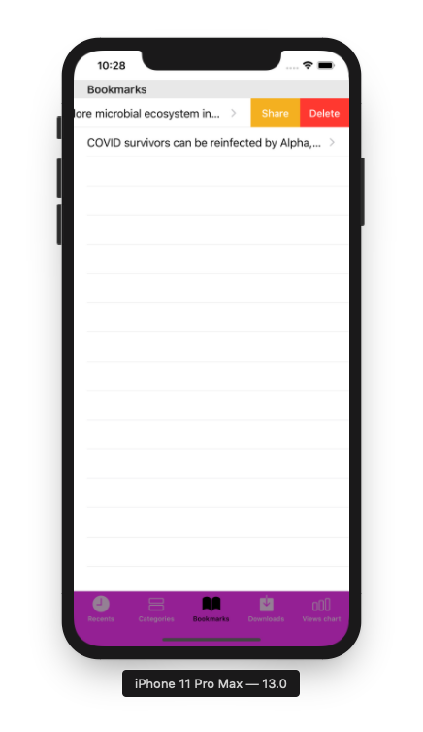

*Image 19: Bookmark Screen with Swipe Actions*

#### Functional Requirements

|  |  |  |  |
| --- | --- | --- | --- |
| **Item** | **Description** | **Action** | **Response** |
| **Bookmark Screen** | Bookmark screenhas 1 tabBarController, 5 tabBarItem and 1 UITableView to display a list of bookmarked news:   * UITableView has a title for header: “Bookmarks” * UITableViewCell News contains these components: * News title label * Share Swipe Action * Delete Swipe Action * TabBarController contains 5 tabBarItems: * Recents TabBarItems * Categories TabBarItems * Bookmark TabBarItems * Download TabBarItems * View chart TabBarItems | N/A | N/A |
| **UITableView Bookmark news** | **UITableView Bookmark news**  contains a title “Bookmarks” | N/A | N/A |
| **UITableView cell Bookmark News** | - Using to display news details  - View cell contains News Title labels | Tap on the view cell | Display news details |
| **View cell News when swipe from right to left** | - Using to display news details and other options with this news  - View cell contains following components:   * Title news labels * Share Swipe Action * Delete Swipe Action | Swipe from right to left | Display 2 Swipe Actions: Delete and Share |
| **Delete Swipe Action** | - Using to delete news from Bookmark news list  - The download button is on the right of Share Swipe action  - The download Swipe action has a red background and white text color | Tap on the **Delete** Swipe Action | Delete selected news from Bookmark list by using Delegate of AppDel |
| **Share Swipe Action** | - Using to display a list of social network options for sharing  - TheShareSwipe Action  is on the right of the right of title label  - The share Swipe Action has an orange background and white text color | Tap on the **Share** Swipe Action | Display a list of social network options for sharing |
| **TabBarController** | TabBarController contains 5 tabBarItems:   * Recents TabBarItems * Categories TabBarItems * Bookmark TabBarItems * Download TabBarItems * View chart TabBarItems | N/A | N/A |
| **Recents TabBarItems** | -Using to display 20 latest news | Tap on the **Recents TabBarItem** | Display a list of 20 latest news |
| **Categories TabBarItems** | - Using to display category options  - Categories:   * Heath * Science * Entertainment   Technology | Tap on **Categories TabBarItems** | Display categories screen |
| **Bookmark TabBarItems** | - Using to display the list of bookmarks news on device | Tap on **Bookmark TabBarItems** | Display screen contians a list of bookmark news |
| **Download TabBarItems** | - Using to display the list of download news on the smartphone | Tap on **Download TabBarItems** | Display screen contians a list of download news |
| **View chart TabBarItems** | Using to show a chart of user View for each category | Tap on **View chart TabBarItems** | Show a screen display a chart of user View for each category |

### Feature/Component #7: Share Screen

#### User Interfaces



*Image 20: Share news screen*

#### Functional Requirements

|  |  |  |  |
| --- | --- | --- | --- |
| **Item** | **Description** | **Action** | **Response** |
| **Share Screen** | Share Screen has 7 buttons and a title   * Reminder button * Copy button * Save to Files button * Edit Actions button * Close button * More button * Title: URL news | N/A | N/A |
| **Reminder button** | -Using to record reminders to the user's phone | Tap on button | Record reminders to the user's phone |
| **Copy button** | -Using to copy the news link to the clipboard on the user's phone | Tap on button | Copy the news link to the clipboard on the user's phone |
| **Save to files button** | -Using to store information into a file and then add it to the user's phone memory | Tap on button | Store information into a file and then add it to the user's phone memory |
| **Edit action** **button** | -Using to edit action | Tap on button | Edit action |
| **Close button** | -Using to close share screen | Tap on button | Close share screen |
| **More button** | -Using to show options | Tap on button | Show options |
| **URL Title news** | -URL news | N/A | N/A |

### Feature/Component #8: Download list Screen

#### User Interfaces

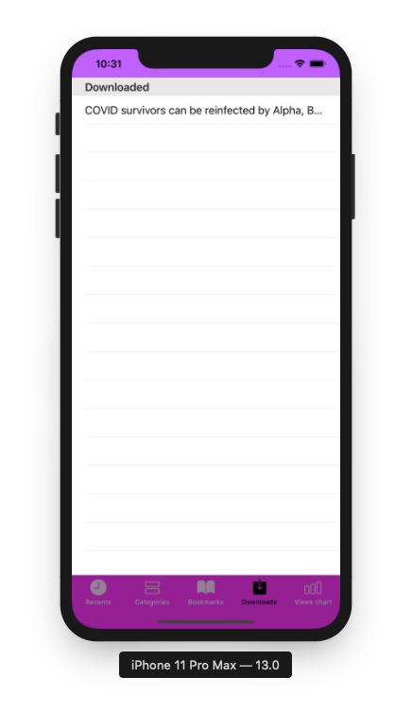

*Image 21: Download list screen*

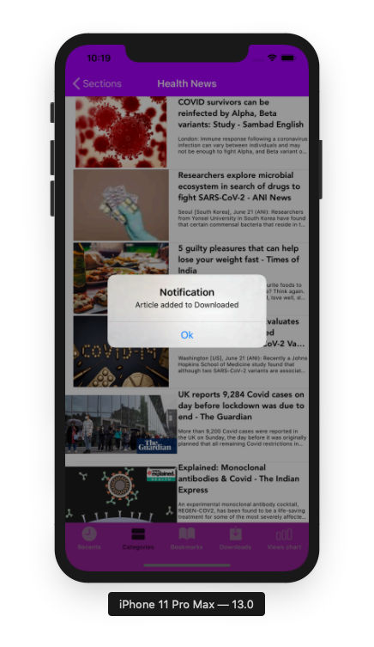

*Image 22: Notification when downloaded news successfully*

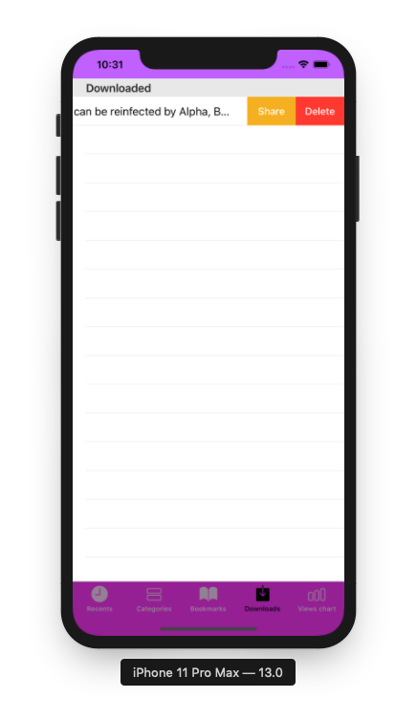

*Image 23: Download Screen with Swipe Action*

#### Functional Requirements

|  |  |  |  |
| --- | --- | --- | --- |
| **Item** | **Description** | **Action** | **Response** |
| **Download Screen** | Download screenhas 1 tabBarController, 5 tabBarItem and 1 UITableView to display a list of bookmarked news:   * UITableView has a title for header: “Downloaded” * UITableViewCell News contains these components: * News title label * Share Swipe Action * Delete Swipe Action * TabBarController contains 5 tabBarItems: * Recents TabBarItems * Categories TabBarItems * Bookmark TabBarItems * Download TabBarItems * View chart TabBarItems | N/A | N/A |
| **UITableView Bookmark news** | **UITableView Bookmark news**  contains a title “Downloaded” | N/A | N/A |
| **UITableView cell Bookmark News** | - Using to display news details  - View cell contains News Title labels | Tap on the view cell | Display news details |
| **View cell News when swipe from right to left** | - Using to display news details and other options with this news  - View cell contains following components:   * Title news labels * Share Swipe Action * Delete Swipe Action | Swipe from right to left | Display 2 Swipe Actions: Delete and Share |
| **Delete Swipe Action** | - Using to delete news from Bookmark news list  - The download button is on the right of Share Swipe action  - The download Swipe action has a red background and white text color | Tap on the **Delete** Swipe Action | Delete selected news from Download list by using Delegate of AppDel |
| **Share Swipe Action** | - Using to display a list of social network options for sharing  - TheShareSwipe Action  is on the right of the right of title label  - The share Swipe Action has an orange background and white text color | Tap on the **Share** Swipe Action | Display a list of social network options for sharing |
| **TabBarController** | TabBarController contains 5 tabBarItems:   * Recents TabBarItems * Categories TabBarItems * Bookmark TabBarItems * Download TabBarItems * View chart TabBarItems | N/A | N/A |
| **Recents TabBarItems** | -Using to display 20 latest news | Tap on the **Recents TabBarItem** | Display a list of 20 latest news |
| **Categories TabBarItems** | - Using to display category options  - Categories:   * Heath * Science * Entertainment   Technology | Tap on **Categories TabBarItems** | Display categories screen |
| **Bookmark TabBarItems** | - Using to display the list of bookmarks news on device | Tap on **Bookmark TabBarItems** | Display screen contians a list of bookmark news |
| **Download TabBarItems** | - Using to display the list of download news on the smartphone | Tap on **Download TabBarItems** | Display screen contians a list of download news |
| **View chart TabBarItems** | Using to show a chart of user View for each category | Tap on **View chart TabBarItems** | Show a screen display a chart of user View for each category |

### Feature/Component #9: Getting News Screen

#### User Interfaces

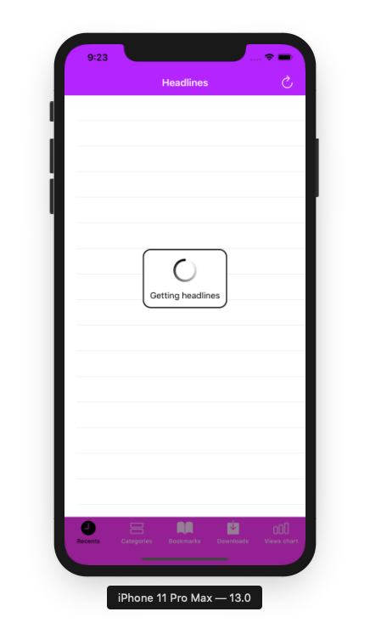

*Image 24: Getting News screen*

#### Functional Requirements

|  |  |  |  |
| --- | --- | --- | --- |
| **Item** | **Description** | **Action** | **Response** |
| **Getting News screen** | Getting News screen has:   * Title: Getting news * Icon: Loading * Text: Black * Background: Light blue | N/A | N/A |

### Feature/Component #10: View chart Screen

#### User Interfaces

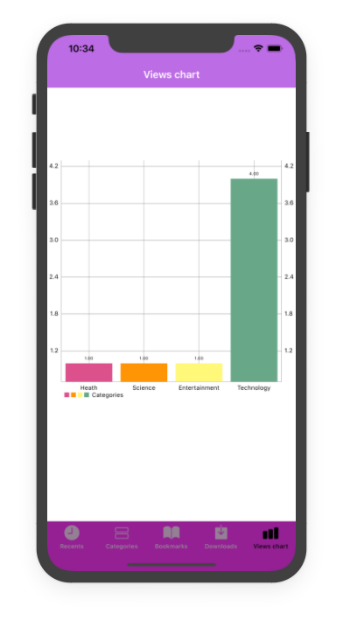

*Image 25: View chart screen*

#### Functional Requirements

|  |  |  |  |
| --- | --- | --- | --- |
| **Item** | **Description** | **Action** | **Response** |
| **Chart Screen** | Chart screenhas 1 tabBarController, 5 tabBarItem and 1 chart:   * TabBarController contains 5 tabBarItems: * Recents TabBarItems * Categories TabBarItems * Bookmark TabBarItems * Download TabBarItems * View chart TabBarItems * Categories views chart | N/A | N/A |
| **Categories View chart** | -Using to display a chart of Views for each category | N/A | N/A |
| **TabBarController** | TabBarController contains 5 tabBarItems:   * Recents TabBarItems * Categories TabBarItems * Bookmark TabBarItems * Download TabBarItems * View chart TabBarItems | N/A | N/A |
| **Recents TabBarItems** | -Using to display 20 latest news | Tap on the **Recents TabBarItem** | Display a list of 20 latest news |
| **Categories TabBarItems** | - Using to display category options  - Categories:   * Heath * Science * Entertainment   Technology | Tap on **Categories TabBarItems** | Display categories screen |
| **Bookmark TabBarItems** | - Using to display the list of bookmarks news on device | Tap on **Bookmark TabBarItems** | Display screen contians a list of bookmark news |
| **Download TabBarItems** | - Using to display the list of download news on the smartphone | Tap on **Download TabBarItems** | Display screen contians a list of download news |
| **View chart TabBarItems** | Using to show a chart of user View for each category | Tap on **View chart TabBarItems** | Show a screen display a chart of user View for each category |

### Feature/Component #11: No Internet Connection Screen

#### User Interfaces

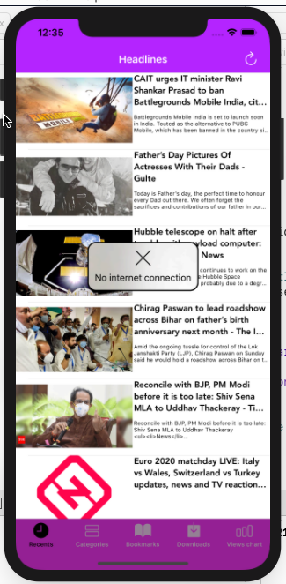

*Image 26: No Internet Connection screen*

#### Functional Requirements

|  |  |  |  |
| --- | --- | --- | --- |
| **Item** | **Description** | **Action** | **Response** |
| **No Internet Connection screen** | No Internet Connection screen has:   * Title: No internet connection * Icon X * Text: Black | N/A | N/A |

# Database Design

Our application use CoreData to save Download and Bookmark news, we also use api URL to get all latest news so we actually don’t need to use database. Except views chart function, here we only use a simple table to save data.

views

|  |
| --- |
| Id_phone (PRIMARY KEY) |
| Headlth_view (INT) |
| Science_view (INT) |
| Entertainment_view (INT) |
| Technology_view (INT) |

# Other Constraints for Application

This application doesn’t require any system requirements, but it only can be runned in version from 14.1 to 14.5.

This app only supports screen orientation in portrait mode.

***---------- End of Document ----------***